The International Journal of the Nigerian Institutes of Architects (IJNIA) serves as a dynamic platform for advancing architectural scholarship, professional innovation, and interdisciplinary built environment research. The journal seeks to foster meaningful dialogue and knowledge exchange among researchers, architects, industry professionals, policymakers, and global stakeholders in addressing contemporary challenges facing buildings, cities, infrastructure, and communities. Through its focus on sustainable design, resilient urban development, digital transformation, emerging technologies, and socially responsive architectural practice, IJNIA aims to promote transformative research and professional knowledge that contribute to adaptive, inclusive, intelligent, and sustainable built environments. Style Name [IJNIA- Office use only, Century Gothic, 7, Italics] | Research Article/ Review Article/ Perspective Article (Remove where relevant)
 | Insert Your Title Here and Please Do Not Change the Template or Any of Its Styles: Introduce Subtitle Here Where Relevant [Title, Century Gothic Display (Headings),16, Bold]
 | Firstname Lastname¹, Firstname Lastname², Firstname Lastname³, Firstname Lastname⁴ [Author Names, Century Gothic, 10, Bold]
Affiliation 1
Affiliation 2
Affiliation 3
Affiliation 4
Correspondence: e-mail@e-mail.com [Affiliation, Century Gothic, 9]

 | - Abstract (250 words) Style Name [Abstract, Keywords Century Gothic, 10, Bold]
Copyright: Copyright: © 2026 by the authors.  IJNIA is an open-access journal distributed under the terms of the Creative Commons Attribution 4.0 International License (CC BY 4.0). View this license’s legal deed at https://creativecommons.org/licenses/by/4.0/   | All submissions must include a 250-word abstract that clearly and concisely summarises your research. The abstract should include all essential components to effectively communicate your research's essence. Begin by articulating the main objective and rationale of your study, postulating the problem or research question you aim to address and explaining its significance within the discipline. Outline the research design, methods, and procedures employed, including data collection techniques and any theoretical frameworks, ensuring sufficient clarity for understanding how the research was conducted. Summarise the key findings and discoveries, highlighting the most significant data points and outcomes that advance knowledge in the field the article addresses. Describe novel contributions and unique aspects of your study, emphasising what sets your research apart from the existing body of knowledge and how it advances the field. Acknowledge any limitations encountered during your research, such as methodological constraints or data limitations, and demonstrate the implications these may have for future studies or the interpretation of the research findings. Elucidate the real-world applications and practical relevance of your research findings, detailing how your study can be applied in practice within architecture, building, construction, or urban studies. Finally, outline the potential social impact of your research on society or specific social groups, highlighting broader societal benefits or transformations resulting from your research, such as improvements in urban living conditions or contributions to sustainable development. Complying with these guidelines, your abstract will effectively communicate the key aspects of your research and will ensure clarity and coherence for readers and reviewers. [Abstract, Keywords Century Gothic, 9]
Received: dd/mm/yyyy
Revised: dd/mm/yyyy
Accepted: dd/mm/yyyy
Published: dd/mm/yyyy

Volume: xx
Issue: xx
Pages: pp-pp
 | Keywords: keyword 1; keyword 2; keyword 3 (Provide a minimum of 4 and up to 8 keywords that encapsulate the main topics of the manuscript.) [Abstract, Keywords, Century Gothic, 9]
Cite this article:  Lastname, F. M., & Lastname, F. M. (Year). Title of the article. Title of the Journal, Volume (Issue), Page range. https://doi.org/xx.xxx/yyyy | - Highlights  - Provide three key highlights that capture the essence of the article and the lessons learned from the findings; each highlight should be one sentence not exceeding 100 characters.  - Provide three key highlights that capture the article's essence and the lessons learned from findings.  - Provide three key highlights that capture the article's essence, and the lessons learned from findings. [Highlights-bulleted list, Century Gothic, 9]

Section 1- Introduction [1 Heading, Century Gothic, 16, Bold]
When writing the introduction of your article, begin by situating your study within a broad context to emphasise its importance. Clearly define the purpose of your work and its significance within its field. Incorporate your research questions, objectives, or aims to provide a clear direction for your study. Demonstrate a considered outline of the current state of the research field, carefully citing key publications to establish the foundation of your study. Where applicable, highlight any controversial or diverging hypotheses to showcase the complexity and different perspectives within the topic. Conclude the introduction by briefly mentioning the main aim of your work and summarising the principal process and conclusions you intend to draw. Strive to make the introduction accessible and comprehensible to academics and professionals outside your specific research area by minimising specialised jargon and clearly explaining concepts. Additionally, ensure that references adhere to APA 6th edition modified guidelines, utilising author-date in-text citations—for example, (Peters, 2020) or (Peters & McGee, 2024). By following these guidelines, your introduction will effectively set the stage for what is coming next and the rest of the article, engage your readers, and provide a clear roadmap. [Text (Body)-IJNIA, Century Gothic, 11]

Section 2 -Literature Review [1 Heading, Century Gothic, 16, Bold]
This section establishes the intellectual and theoretical basis for the study, providing a structured analysis of key concepts, relevant theories, and existing frameworks that inform the research. It critically reviews the literature to position the study within the broader academic discourse, identifying gaps the research seeks to address. Additionally, it introduces a conceptual model that guides the study’s approach, offering a lens through which the research problem is examined. [Text (Body)-IJNIA, Century Gothic, 11]

Defining Key Concepts [1.1 Heading, Century Gothic, 14, Bold]
This subsection defines the core terms and constructs that shape the study. Definitions should be derived from established literature and contextualised within the study’s scope. [Text (Body)-IJNIA, Century Gothic, 11]
What to include:
- A discussion of how key terms have been defined in previous studies.
- Variations in definitions across disciplines (if relevant).
- Justification for the operational definitions used in the research.
- Examples of how these concepts manifest in real-world contexts.

Existing Theories and Frameworks [1.1 Heading, Century Gothic, 14, Bold]
This subsection reviews the dominant theories and frameworks used to study similar phenomena. It helps establish a foundation for understanding the study’s theoretical positioning. [Text (Body)-IJNIA, Century Gothic, 11]
What to include:
- Overview of relevant theories relevant to the research topic.
- A critical discussion of how these theories explain or contribute to the research problem.
- Comparisons between different theoretical approaches and their strengths/limitations.
- How these frameworks have been applied in prior studies.

Knowledge Gaps and Research Opportunities [1.1 Heading, Century Gothic, 14, Bold]
This subsection identifies gaps in the existing literature that justify the need for the present study. It highlights areas where theoretical or empirical contributions are still needed. [Text (Body)-IJNIA, Century Gothic, 11]
What to include:
- Analyse inconsistencies, contradictions, or underexplored aspects in existing research.
- Identification of emerging trends that require further study.
- Discussion on why these gaps matter and their implications for theory and practice.
- How does the current study address these gaps and contribute to the field?

Proposed Conceptual Model [1.1 Heading, Century Gothic, 14, Bold]
This subsection presents the study’s conceptual model, which integrates insights from the literature to propose a framework for analysis. It provides a structured way to examine the research problem. [Text (Body)-IJNIA, Century Gothic, 11]
What to include:
- A visual representation (e.g., a diagram) of the proposed conceptual model.
- Explanation of how different components of the model interact.
- Justification for the selection of specific theories or constructs.
- Discussion on how the model guides the study’s research questions or hypotheses.

Methodology [1 Heading, Century Gothic, 16, Bold]
The methodology section should begin by clearly outlining the research design selected for your study, whether qualitative, quantitative, or mixed-methods, and provide a rationale for this choice in the context of your research objectives. Describe the specific methods and procedures used to collect data, including details on data sources, sampling techniques, and any tools or instruments employed. Explain the theoretical frameworks or models that guide your research approach if applicable. Including a diagram to illustrate your methodological framework can enhance clarity and provide a visual representation of the research process, aiding readers in understanding the overall structure of your study. [Text (Body)-IJNIA, Century Gothic, 11]
Following the description of data collection, detail the procedures used for data analysis, specifying the techniques and software tools utilised to interpret the data. Discuss how these methods are appropriate for addressing your research questions and how they contribute to the validity and reliability of your findings. Additionally, address any ethical considerations relevant to your study, such as obtaining informed consent or ensuring participant confidentiality. Acknowledge any limitations within your methodology that could impact the results and suggest how future research might address these challenges. By providing a comprehensive and transparent methodology supported by visual aids like diagrams, you enable readers to understand the processes behind your research and assess the robustness of your conclusions. [Text (Body)-IJNIA, Century Gothic, 11]

Results- Key Findings [1 Heading, Century Gothic, 16, Bold]
The results section should present the key findings of your study in a clear and organised manner without delving into interpretation or discussion. Begin by outlining the primary outcomes related to your research objectives or hypotheses, ensuring that each result is directly tied to the research questions posed. Use appropriate tables, figures, and charts to effectively display quantitative data, and ensure that all visual aids are clearly labelled and referenced within the text. For qualitative studies, present themes or patterns that emerged from the data, supported by relevant excerpts or examples. Organise the results logically, often following the sequence of your methodology or the order of your research questions, to provide a coherent flow that is easy for readers to follow. [Text (Body)-IJNIA, Century Gothic, 11]
In addition to presenting the data, highlight the most significant findings contributing to advancing knowledge in architecture and urbanism. Ensure that all information is relevant and necessary, avoiding including raw data or overly detailed information that may overwhelm the reader. Summarise the data succinctly, providing a narrative that guides the reader through the results without offering interpretations or conclusions, which should be reserved for the discussion section. Maintain consistency in reporting and use precise language to enhance clarity and comprehension. By presenting your results in a structured and transparent manner, you facilitate understanding and provide a solid foundation for your research's subsequent analysis and discussion. [Text (Body)-IJNIA, Century Gothic, 11]
Bulleted lists look like this:
- First bullet [Bulleted List- IJNIA, Century Gothic, 11]
- Second bullet
- Third bullet
Numbered lists can be added as follows:
- First item [Numbered List-IJNIA, Century Gothic, 11]
- Second item
- Third item

Figures, Tables and Schemes [1.1.1 Heading, Century Gothic, 12, Bold]
When preparing figures and tables for your manuscript, it is essential to ensure they are clear, informative, and seamlessly integrated into your research article. Each figure and table should be numbered consecutively (e.g., Figure 1, Table 1) and accompanied by a concise, descriptive title that accurately reflects its content. Titles should be placed above tables and below figures, following the formatting guidelines of APA 6th Edition modified or the specific requirements of the Architecture, Buildings, Construction and Cities (IJNIA) journal. Ensure that all figures and tables are referenced appropriately within the text, directing readers to examine them for supporting evidence or detailed information. The placement of figures and tables should enhance the flow of your manuscript, typically positioned near the relevant text, to provide immediate context and avoid disrupting the narrative. [Text (Body)-IJNIA, Century Gothic, 11]
Each figure and table must include a clear and comprehensive caption explaining its purpose and content without requiring the reader to refer to the main text. For tables, use horizontal lines to separate headers from data and maintain consistent alignment for readability. Figures, such as graphs, charts, and images, should be high resolution (300 dpi or higher) to ensure clarity in digital and printed formats. Use legible fonts and appropriate colour schemes to enhance comprehension and include legends or labels where necessary to define symbols, abbreviations, or units of measurement. Avoid overcrowding figures and tables with excessive information; instead, focus on presenting data in a straightforward and accessible manner. Additionally, ensure that all visual elements comply with ethical standards, including obtaining necessary permissions for reproduced material and maintaining participant confidentiality where applicable. [Text (Body)-IJNIA, Century Gothic, 11]

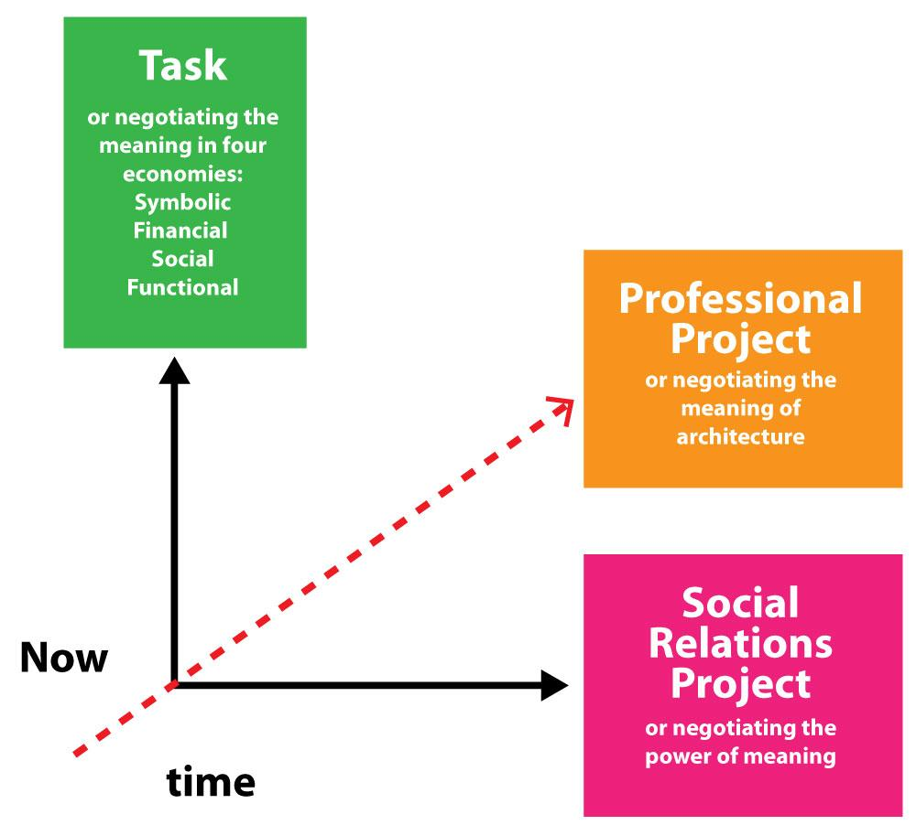
Figure 1. This is a figure. Please follow this formatting style [Caption-IJNIA, Century Gothic, 9, Italic]

Table I. This is a table. Tables should be placed in the main text near to the first time they are cited. [Caption-IJNIA, Century Gothic, 9, Italic]
Title 1 | Title 2 | Title 3
entry 1 | data | data
entry 2 | data | data ¹
entry 1 | data | data
entry 2 | data | data ¹
¹ Tables may have a footer.
[Table Text- IJNIA, Century Gothic, 9, Italic]

Discussion [1 Heading, Century Gothic, 16, Bold]
The discussion section should begin by interpreting and contextualising the key findings of your study within the broader field of architecture and urbanism. Explain how your results address the research questions or objectives outlined in the introduction, highlighting any significant patterns, trends, or unexpected outcomes. Compare and contrast your findings with existing literature, demonstrating how your work corroborates, extends, or challenges previous studies. This critical analysis helps to situate your research within the current academic discourse and underscores its contribution to advancing knowledge in the field. [Text (Body)-IJNIA, Century Gothic, 11]
In addition to interpreting the results, the discussion should explore your study's practical and theoretical implications. Discuss how your findings can inform future research, policy-making, or professional practice in architecture and urban planning. Acknowledge any limitations encountered during your research, such as methodological constraints or data limitations, and explain how these factors may influence the interpretation of your results. Suggest areas for further investigation to address these limitations and build upon your work. Conclude the discussion by summarising the principal insights gained from your study and reiterating their significance, ensuring that your conclusions are well-supported by the evidence presented. [Text (Body)-IJNIA, Century Gothic, 11]

Conclusions [1 Heading, Century Gothic, 16, Bold]
The conclusions section should begin by succinctly summarising the key findings of your study, directly addressing the research objectives or questions outlined in the introduction. Emphasise how these results contribute to the field of architecture and urbanism, highlighting the study's unique contributions and the advancements it brings to existing knowledge. This summary should reinforce the significance of your research and demonstrate how it fills the identified gaps or resolves the issues discussed in the literature review. Avoid introducing new data or information; instead, focus on distilling the essence of your research outcomes to provide a clear and concise closure to your study. [Text (Body)-IJNIA, Century Gothic, 11]
In addition to summarising the findings, the conclusions should explore the broader implications of your work, both theoretical and practical. Discuss how your results can inform future research, influence policy-making, or impact professional practices within architecture and urban planning. Acknowledge any limitations encountered during your study and suggest areas for further investigation to address these challenges and build upon your work. Conclude by reiterating the importance of your research and its potential to drive meaningful change or innovation in the field. By providing a comprehensive and thoughtful conclusion, you ensure that readers leave with a clear understanding of your study’s value and its contributions to the discipline. [Text (Body)-IJNIA, Century Gothic, 11]
At the end of your manuscript, please ensure that you include the following items, which should be anonymised during the submission and review stages.

Acknowledgements [Abstract, Keywords Century Gothic, 10, Bold]
Recognise any support not covered by author contributions or funding, such as administrative assistance, technical support, or material donations. Mention individuals or organisations that contributed to the research and manuscript writing but not eligible to be considered as authors. [Abstract, Keywords Century Gothic, 9]
Funding
Declare whether the research received external funding or was funded by specific agencies, including grant numbers if applicable. Ensure the accurate spelling of funding agency names.
Data Availability Statement
Detail where the data supporting your research results can be accessed, including links to publicly archived datasets. If data is unavailable, provide a clear statement explaining the reasons, such as privacy or ethical restrictions.
Conflicts of Interest
Declare any potential conflicts of interest or state, “The authors declare no conflict of interest.” Include details about the role of funders in the research, data collection, analysis, writing, or publication decisions if applicable.

References
All submissions to the Architecture, Buildings, Construction and Cities (IJNIA) Journal must adhere to the APA 6th Edition modified style for referencing. For those using Endnote, the IJNIA style can be downloaded from the website. You can also follow the examples below. [References, Century Gothic, 10]

EXAMPLES:
Book
Smith, J. A. (2018). Cognitive behaviour therapy: A modern approach (2nd ed.). New York, NY: Springer. ISBN: 978-3-16-148410-0

Edited Book
Brown, T. (Ed.). (2013). Advances in social psychology research. London, UK: Springer. ISBN: 978-1-4039-1389-5
Book with Edition and Editor
Miller, R., & Cohen, S. (2020). Handbook of cognitive science (T. Lewis, Ed., 3rd ed.). Oxford, UK: Oxford University Press. ISBN: 978-0-19-876689-2

Chapter in an Edited Book
Garcia, M. (2016). Emotional intelligence in young adults. In R. Miller & S. Cohen (Eds.), Handbook of psychology and behaviour (2nd ed., Vol. 3, pp. 200–225). Oxford, UK: Oxford University Press. doi: 10.xxxx/yyyy

Chapter with Edition and Editor
Miller, R., & Cohen, S. (2020). Memory retention and cognitive function. In T. Lewis (Ed.), Handbook of cognitive science (3rd ed., pp. 45–78). New York, NY: Springer. doi: 10.xxxx/yyyy

Conference Paper (Published- Available Online)
Smith, J. A. (2022). Cognitive flexibility in learning environments. Paper presented at the Annual Conference of Educational Psychology, London, UK. Retrieved from https://www.educationpsychconference.org/papers/cognitive_flexibility.pdf, Last Access: February 20, 2025.

Conference Poster Presentation
Miller, R. (2020). The effect of digital interfaces on cognitive load. Poster session presented at the International Conference on Cognitive Science, Toronto, Canada. Retrieved from https://www.cogsci2020.org/posters/cognitive_load.pdf, Last Access: February 20, 2025.

Conference Proceedings (Published)
Smith, J. A. (2022). Cognitive flexibility in learning environments. In R. Miller & S. Cohen (Eds.), Proceedings of the Annual Conference of Educational Psychology, June 10-12, 2022, London, UK (pp. 45–67). New York, NY: Springer. doi: 10.xxxx/yyyy

Government Report (Online Access)
World Health Organization. (2023). Global mental health strategies (WHO Report No. 2023-45). Retrieved from Geneva, Switzerland: https://www.who.int/reports/mental-health, Last Access: February 20, 2025.

Open-Source Software
Python Software Foundation. (2022). Python (Version 3.10) [Programming language]. Wilmington, DE: Python Software Foundation. Retrieved from https://www.python.org, Last Access: February 20, 2025.

Mobile Application
OpenAI. (2023). ChatGPT (Version 4.0) [Mobile application]. San Francisco, CA: OpenAI. Retrieved from https://www.openai.com, Last Access: February 20, 2025.

Journal Article
Smith, J. A. (2022). The impact of mindfulness on cognitive function. Journal of Psychological Research, 45(2), 123–145. doi: 10.xxxx/yyyy

Online Journal Article DOI
Smith, J. A. (2022). The impact of mindfulness on cognitive function. Journal of Psychological Research, 45(2), 123–145. Retrieved from APA Psychology website: https://www.apa.org/journal/mindfulness, doi: 10.xxxx/yyyy

Online Newspaper Article
Brown, T. (2023, March 10). Climate change and its psychological impact, Feature article. The Guardian. Retrieved from https://www.theguardian.com/climate-psychology, Last Access: February 20, 2025.

Print Newspaper Article
Smith, J. (2022, September 15). The impact of urbanization on mental health, News report. The New York Times, p. A3.

Press Release from an Organization
World Health Organization. (2023). WHO launches new mental health initiative [Press release]. Retrieved from https://www.who.int/news-room/releases, Last Access: February 20, 2025.

Single Podcast Episode
Fridman, L. (Producer). (2023, January 10). The future of AI and human cognition [Podcast episode]. Retrieved from https://www.lexfridman.com/podcast, Last Access: February 20, 2025.

Thesis/Dissertation (ProQuest Database)
Smith, J. A. (2022). Cognitive flexibility in learning environments (Doctoral dissertation), Harvard University, Cambridge, MA. Available from ProQuest Dissertations & Theses Global database. (Document No. 1234567).

Thesis/Dissertation from an Online Database
Brown, T. (2021). Emotional intelligence and leadership performance (Doctoral dissertation) (Publication No. 1234567). Available from ProQuest Dissertations & Theses Global. Retrieved February 20, 2025, from https://www.proquest.com/theses/emotional-intelligence

Web Page with an Individual Author
Smith, J. A. (2023). Cognitive flexibility and decision-making. Harvard Working Papers in Psychology. Retrieved from https://www.harvard.edu/working-papers/cognitive-flexibility, Last Access: February 20, 2025.

Web Page from an Organization (No Individual Author)
World Health Organization. (2022). Global mental health strategies. WHO Reports. Retrieved from https://www.who.int/global-health-strategies, Last Access: February 20, 2025.

  - Disclaimer/Publisher’s Note [Abstract, Keywords Century Gothic, 10, Bold]
The statements, opinions, and data contained in all publications are solely those of the individual author(s) and contributor(s) and do not reflect the views of the Architecture, Buildings, Construction and Cities (IJNIA) Journal and/or its editor(s). IJNIA Journal and/or its editor(s) disclaim any responsibility for any injury to people or property resulting from any ideas, methods, instructions, or products referred to in the content. [Abstract, Keywords Century Gothic, 9]

